**DIFFERENT METHODS TO GET UNIQUE VALUES FROM A LIST:**

Using set () method:

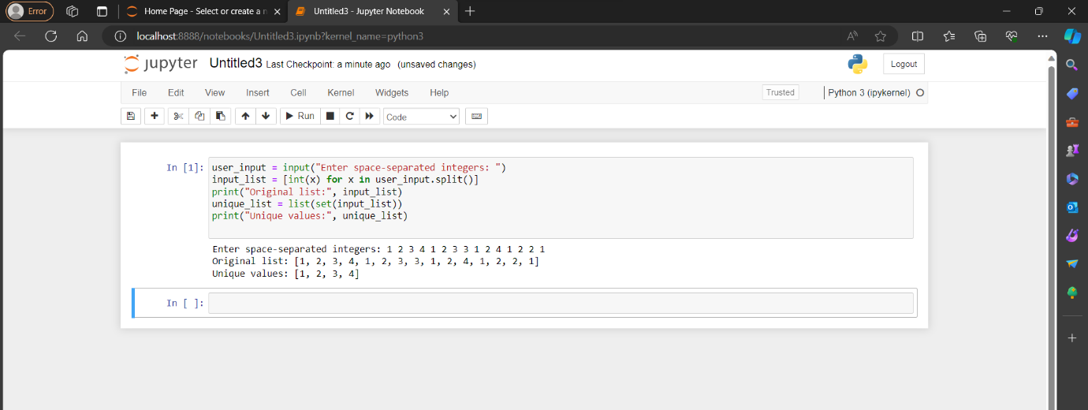

Using reduce () method:

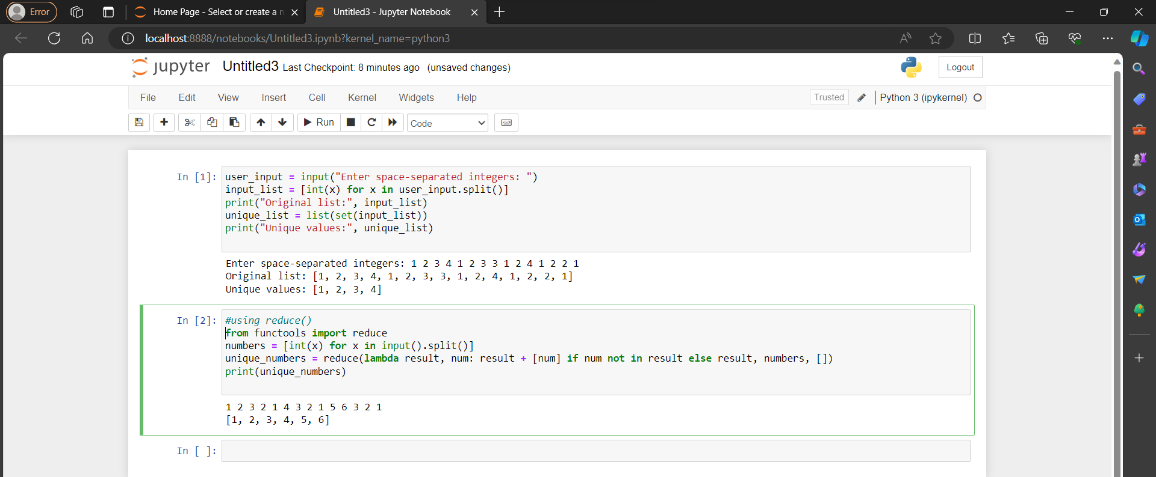

Using operator.Countof () method:

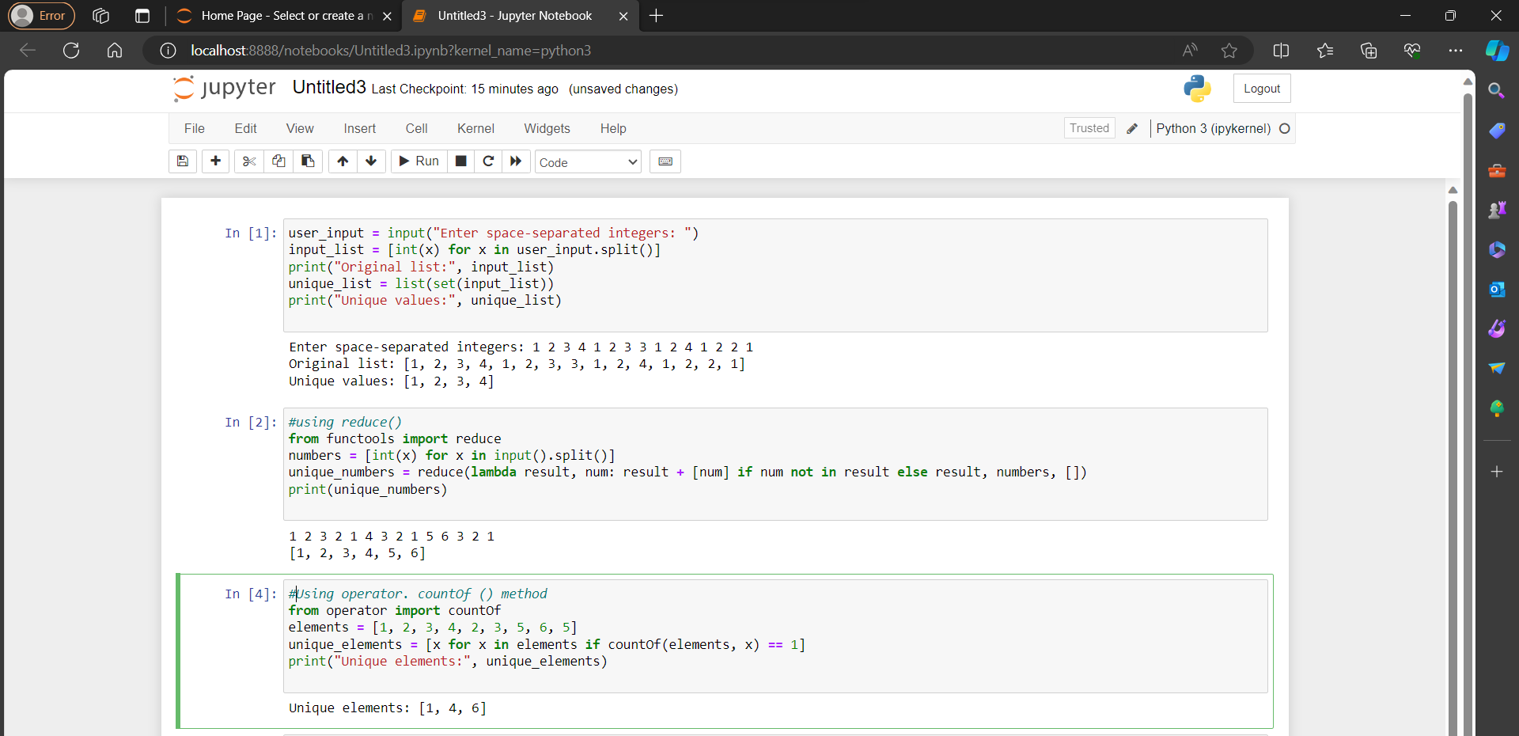

Using pandas module:

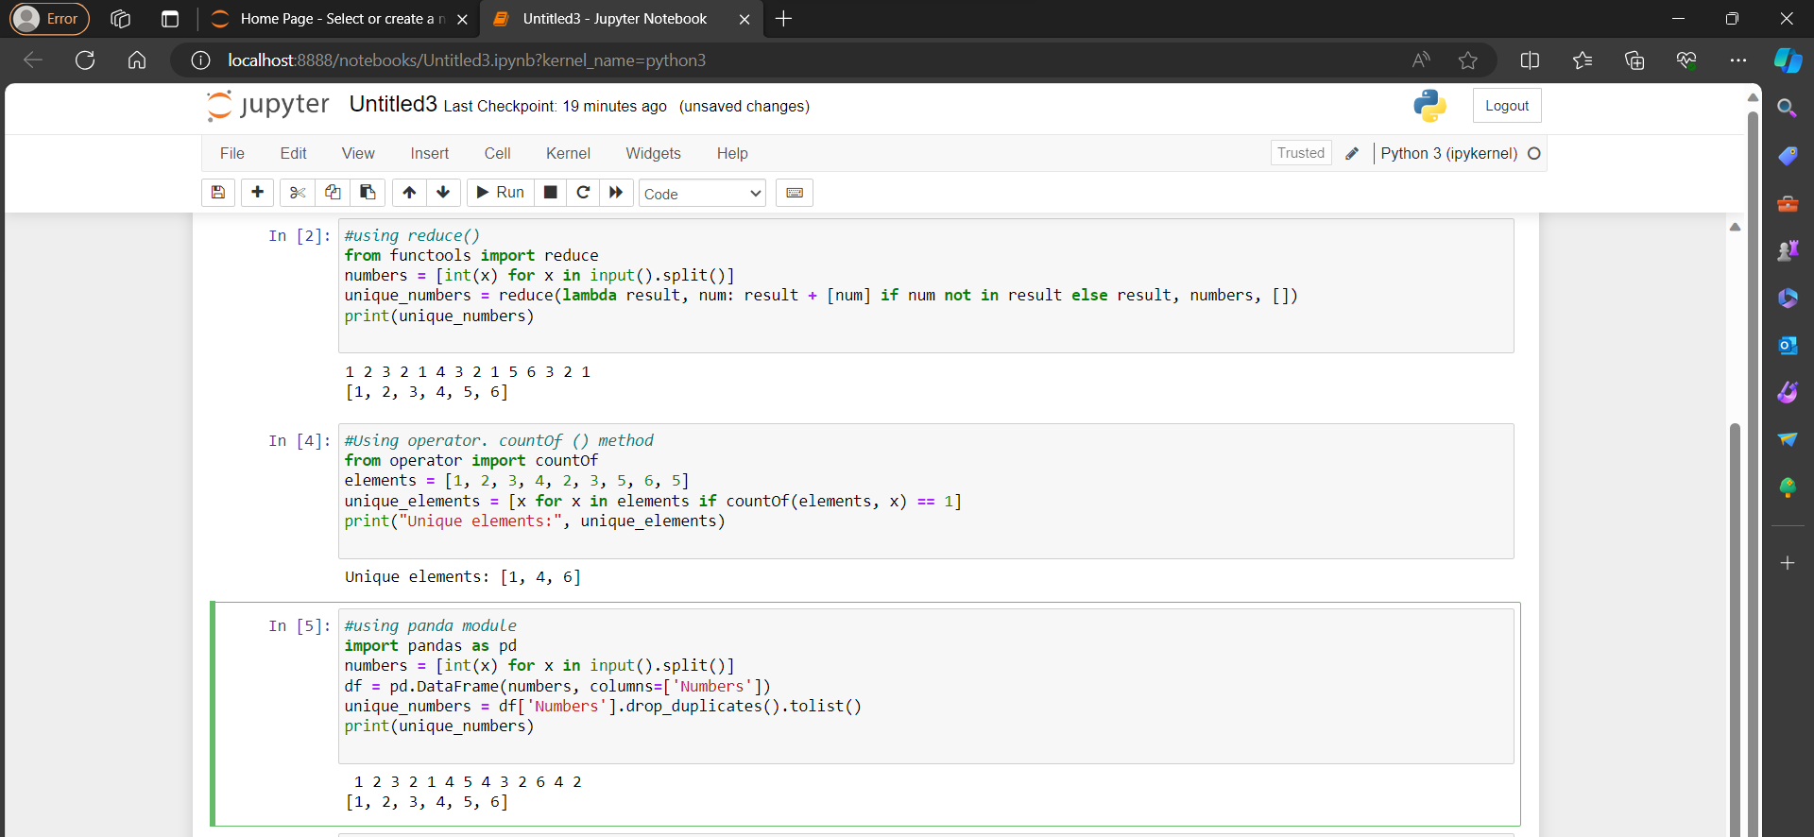

Using Numpy.Unique method :

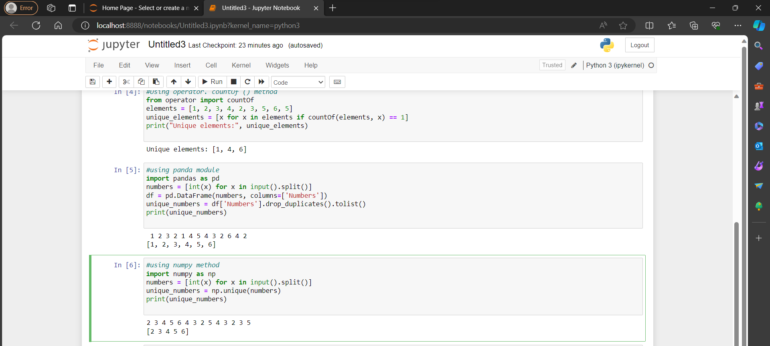

Using collections. Counter () method:

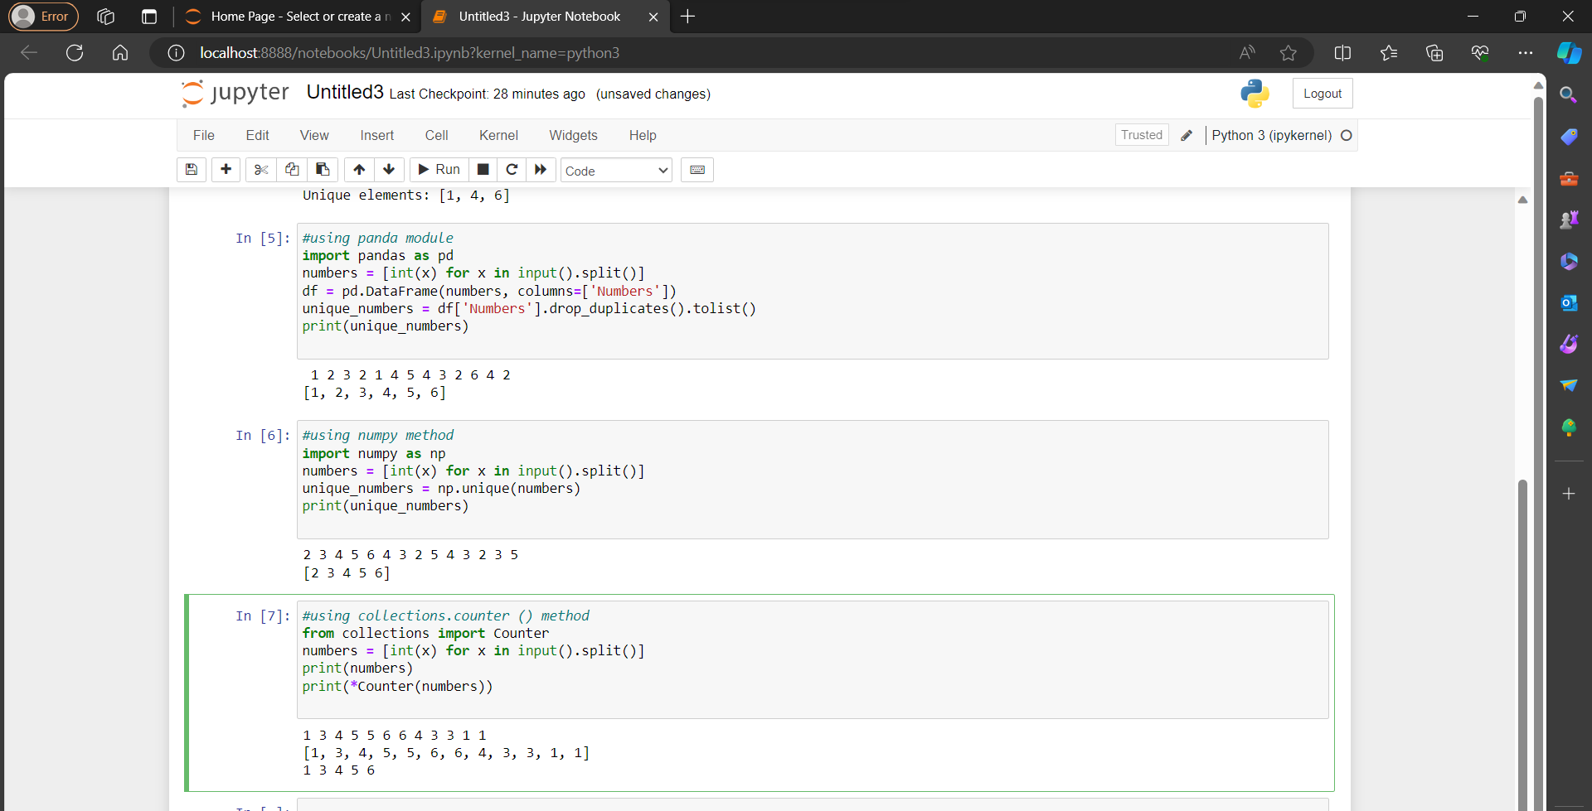

Using dict. Fromkeys ():

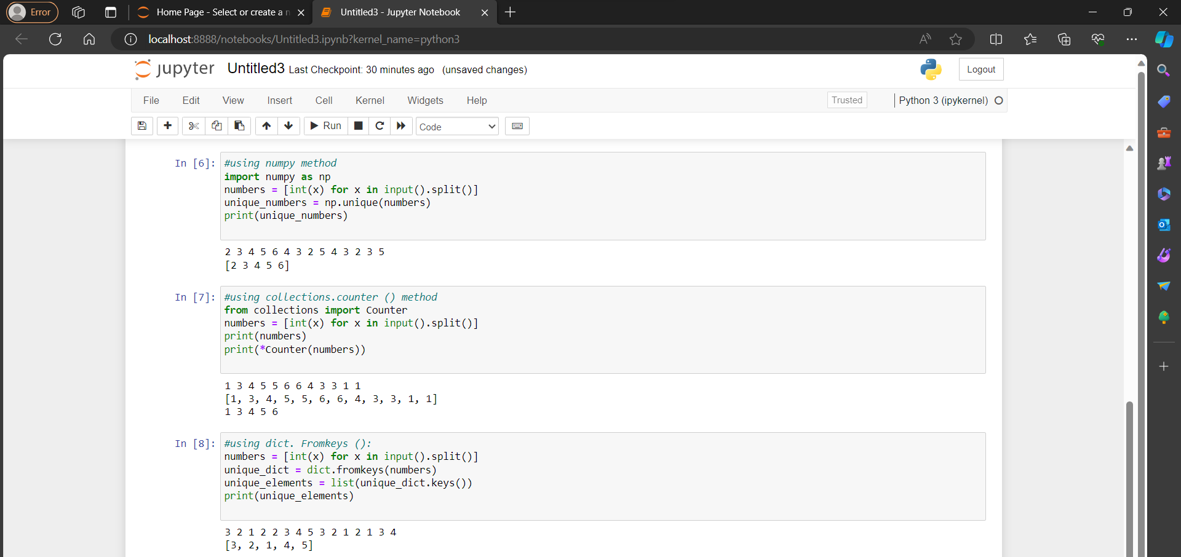

**SORT PYTHON LISTS:**

Using sorted ():

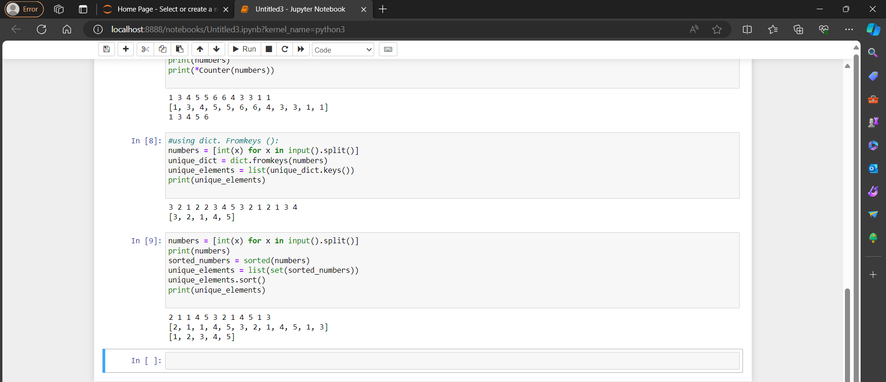

Using sorted () with reverse argument:

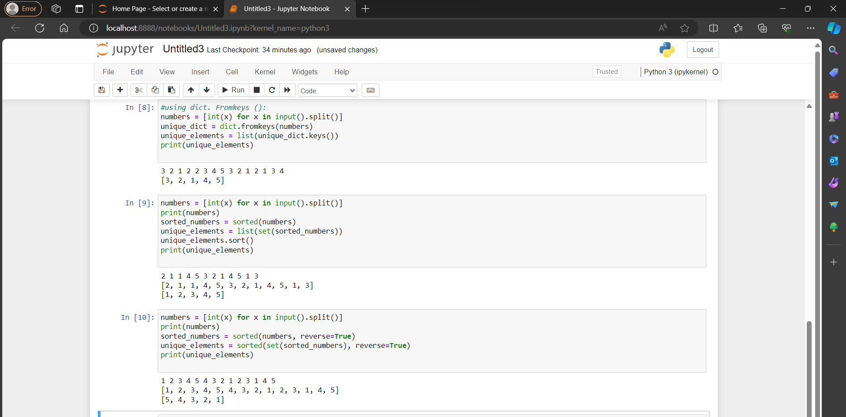

Using sorted () with key argument:

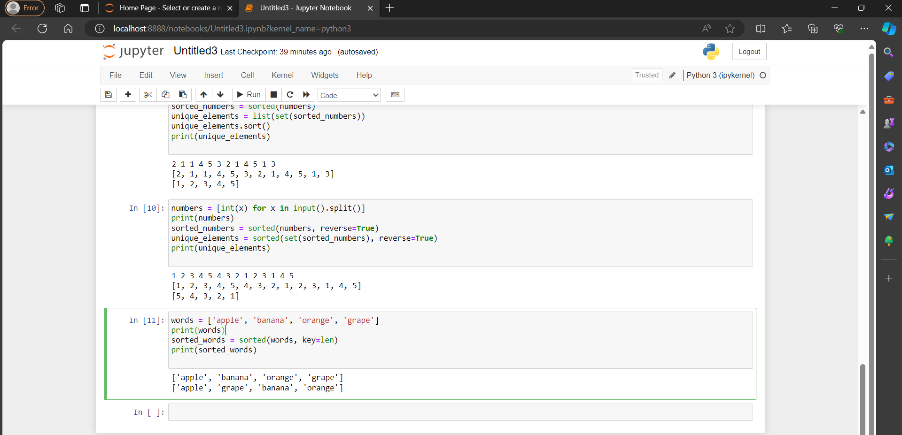

**JSON:**

1. **JSON Definition**: JSON stands for JavaScript Object Notation.
2. **Data Structure Format**: It serves as a format for structuring data.
3. **Communication Usage**: JSON is utilized by various web applications to communicate with each other.
4. **Media Type**: The official media type for JSON is `application/json`.
5. **File Extension**: JSON files are typically saved with the extension `.json`.

**CONVERT JSON STRING TO PYTHON DICTIONARY:**

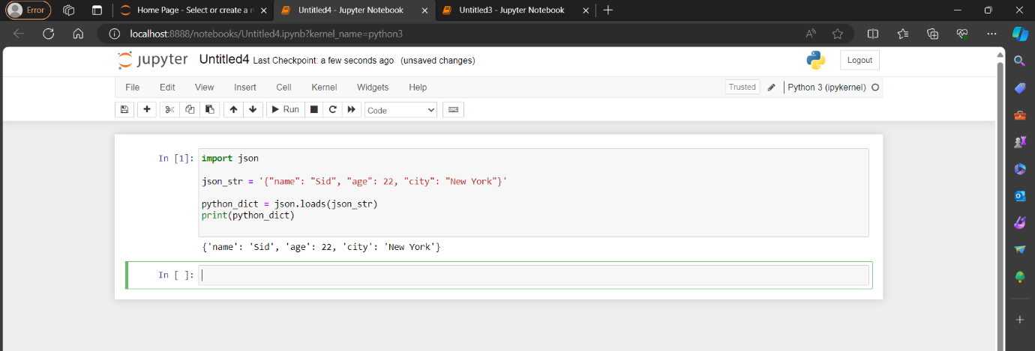

**CONVERT A JSON DATA INSIDE A FILE INTO PYTHON DICTIONARY:**

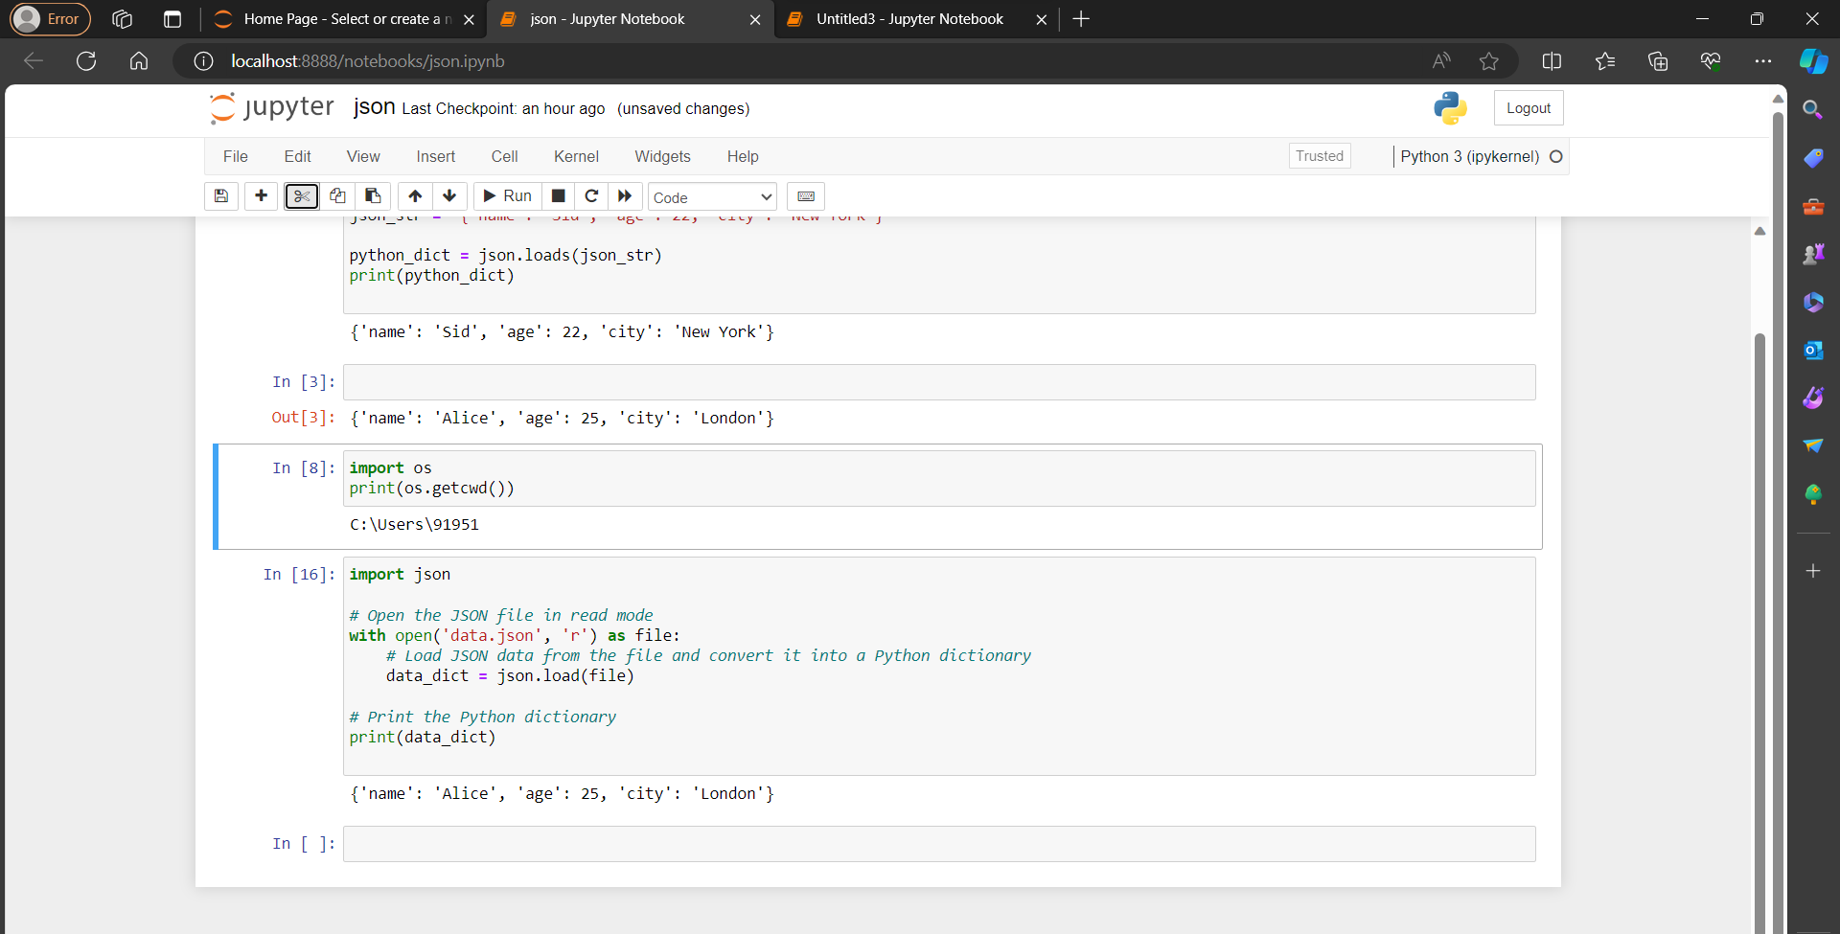

Here the json data is taken from data.json file. And below is the data.json file.

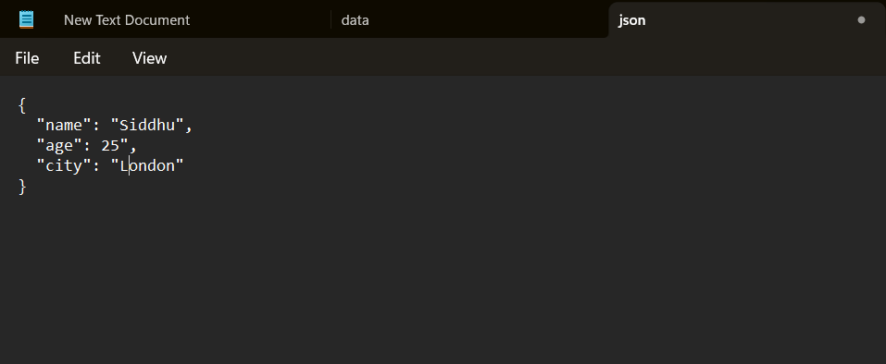

**CONVERT PYTHON DICTIONARY TO JSON:**

